Software Requirements Specification
Version 1.0
May 15, 2025

Symposium Sorting System
Schedify
Brandon Tian, Project Manager
Ethan Cho, Systems Analyst
Chris Wang, Lead Programmer
Daniel Zhang, Lead Tester

Table of Contents
1.0 Introduction
1.1 Purpose
1.2 Intended Audience and Use
1.3 Scope of Project
1.4 Definitions and Acronyms
1.5 References
1.6 Overview of the SRS
2.0 Overall Description
2.1 System Environment
2.2 User Needs
2.3 Assumptions and Dependencies
3.0 Requirements Specification
3.1 Functional Requirements
3.2 External Interface Requirements
3.3 System Features
3.4 Nonfunctional Requirements

1.0 Introduction
Every year at Poolesville High School, seniors in the Science, Math, and Computer Science (SMCS) program present their summer internship experiences at the SMCS Symposium. The responsibility of scheduling these presentations falls to the program’s Junior Committee, which must account for various availability constraints and presider preferences. In previous years, this process has been manually intensive, time-consuming, and error-prone.
A system must be designed to automatically generate clean, organized symposium schedules based on senior input. The system aims to streamline the scheduling process, reduce manual workload, and ensure the output is accessible and usable by Junior Committee members on ChromeOS devices. The system will be developed by a team of four sophomore students at Poolesville High School under the guidance of the Junior Committee and faculty sponsor, Mr. Lee.

1.1 Purpose
This document provides a comprehensive overview of the Symposium Sorting System. It outlines the system’s objectives, key features, user interfaces, functionalities, and technical specifications. It will describe the system’s goals and functionalities, user interfaces, expected behavior, operational limitations, and responses to external inputs. It serves as a foundation for system development, testing, and validation.

All updates to this document are to be noted in the table below.
Version | Date | Author(s) | Notes
1.0 (Draft) | 5/15/2025 | Brandon Tian, Ethan Cho, Chris Wang, Daniel Zhang | Initial draft of SRS completed  Updated functional & nonfunctional requirements
1.1 | TBD | TBD | TBD
TBD | TBD | TBD | TBD

1.2 Intended Audience and Intended Use
The document is intended to help developers, testers, and the client clearly understand how the system should operate. Developers will create the system based on the functionalities and requirements defined in this document. Next, testers will ensure that all produced software systems follow and satisfy all requirements stated in this document. The client may also view this document to ensure that they are satisfied with the system design or to familiarize themselves with how the system should operate.

1.3 Scope of Project
The overall scope of this project is to create a software system that aims to sort and generate symposium schedules for a Junior Committee for the Science, Math, and Computer Science program (SMCS) at Poolesville High School. The system will be designed to efficiently automate the tedious task of creating a schedule for the SMCS senior symposium, which would otherwise have to be created manually. The system will significantly reduce the workload of the Junior Committee while remaining easy to operate. More specifically, this system will be designed to allow the Junior Committee members to be able to quickly generate the schedules of presentations during the symposium according to the scheduling constraints that the seniors have.

1.4 Definitions and Acronyms
SMCS - Science, Math, and Computer Science (Magnet Program)
MCPS - Montgomery County Public Schools
Junior Committee - Organization of Science, Math, and Computer Science program students that assists in the execution of program-specific events
SRS - Software Requirements Specification
UI - User Interface
CSV - Comma-Separated Values (data format)
GitHub - Platform for developing, storing, managing, and sharing code that utilizes Git, an open-source version control system
ChromeOS - Chromebook’s operating system

1.5 References
GeeksforGeeks. (2021, August 27). How to add file uploads function to a webpage in HTML ? GeeksforGeeks. https://www.geeksforgeeks.org/how-to-add-file-uploads-function-to-a-webpage-in-html/

IEEE Guide for Software Requirements Specifications. (1984). IEEE Std 830-1984, 1–26. https://doi.org/10.1109/IEEESTD.1984.119205

‌GitHub. (2024). GitHub.com Help Documentation. Docs.github.com. https://docs.github.com/en

Chrome incompatibilities. (n.d.). Mozilla. Retrieved May 13, 2025, from https://developer.mozilla.org/
en-US/docs/Mozilla/Add-ons/WebExtensions/Chrome_incompatibilities

What is a CSV File and How to Open the CSV File Format. (2019, November 1). FreeCodeCamp.org. https://www.freecodecamp.org/news/what-is-a-csv-file-and-how-to-open-the-csv-file-format/

W3Schools. (n.d.). HTML button tag. Www.w3schools.com. https://www.w3schools.com/tags/tag_button.asp

https://www.smashingmagazine.com/author/christopher-murphy. (2018). A Comprehensive Guide To UI Design — Smashing Magazine. Smashing Magazine. https://www.smashingmagazine.com/2018/02/comprehensive-guide-ui-design/

1.6 Overview of the SRS
The following sections of this document provide a detailed description of the Symposium Sorting System. Section 2 outlines the overall system design, including the environment in which it will operate, the users it will serve, and the specific needs it addresses. Section 3 details the functional and nonfunctional requirements the system must meet to operate effectively. Together, these sections aim to guide the development and evaluation of the system, ensuring that it meets user expectations and delivers a reliable, efficient, and user-friendly experience.

2.0 Overall Description

2.1 System Environment
The Symposium Sorting System is a web-based application hosted under a GitHub Pages domain, designed for accessibility on ChromeOS devices approved by Montgomery County Public Schools (MCPS). As a lightweight website, it does not require any heavy installations or advanced computing resources. However, system performance may vary depending on hardware limitations, and school network restrictions could potentially interfere with file uploads or external resource access during the import/export processes.

2.2 User Needs
This section identifies the primary and secondary users, their roles, and the specific needs that the product will address and fulfill.
Primary Users:
The primary users of this software are Junior Committee members of the Science, Math, and Computer Science (SMCS) program at Poolesville High School. They are responsible for organizing and scheduling the senior symposium presentations. This involves managing scheduling constraints, assigning presentation dates, and ensuring presentations flow smoothly throughout the event. The system should be able to output organized, aesthetically pleasing tables of possible symposium schedules with room numbers, class period, and presentation topics.
Their Needs:
The system must enable the Junior Committee members to:
- Inputting scheduling constraints based on student availability.
- Automatically generating optimized schedules.
- Exporting clean, easy-to-read tables with presentation details (room numbers, time slots, project titles).
Secondary Users:
Secondary users of this software are teachers who can create additional requirements and preferences for scheduling. They are responsible for overseeing the symposiums and monitoring the scheduling process. They may review or adjust the final schedule based on academic or administrative needs.
Their Needs:
The system must enable teachers and admins to:
- Provide oversight and approval of the generated schedules for policy compliance.
- Have transparency into the scheduling process and any adjustments made by the Junior Committee.
- Input administrative constraints.

2.3 Assumptions and Dependencies
Our software assumes that the structure of the symposium (e.g., number of rooms, number of presentations, time slots) will remain stable, and all users have basic computer literacy and access to MCPS-approved devices and tools. Our software will be based on a ChromeOS Framework.

Assumptions and dependencies are labeled using the letters A (for Assumption) and D (for Dependency), followed by a unique numeric identifier beginning with 1.
Assumptions:
A1. Availability of Constraint Data
All senior students will submit their presentation availability and any special constraints before the schedule generation process begins. The format of this data will be standardized for easy interpretation by the system.
Example table from past symposium form responses:
Email Address | Last name | First name | Name of project | Project topic | Availability | Presider of choice
467980@mcpsmd.net | Sha | Andrew | Extracting connectivity signatures of Parkinson’s disease using energy-based analysis | Neuroscience | PD 6, Tuesday, December 19th, PD 2, Thursday, December 21st, PD 4, Thursday, December 21st, PD 5, Thursday, December 21st, PD 6, Thursday, December 21st | Aaron Bhattachan
A2. User Role Integrity
Only authorized personnel (teachers and Junior Committee members) will be provided login credentials or editing permissions. The security model relies on responsible access management.
A3. Device Compatibility Assumption
The system is optimized for ChromeOS devices but assumes users have access to a modern web browser capable of rendering the interface and executing basic JavaScript.

Dependencies:
D1. User Input
Software will require users to submit clear, intelligible constraints that can be easily interpreted and indexed. Incomplete, ambiguous, or inconsistent user-provided constraints may result in scheduling errors or failed generation attempts.
D2. External File Format
Uploaded files should conform to a specific column format as illustrated by the table in A1. Incorrect formatting may cause system errors or incorrect processing.
D3. Scheduling Algorithm Limitation Dependency
The system may not be able to satisfy extremely complex or conflicting constraint sets. In such cases, human review or manual adjustment may be necessary.

3.0 Requirements Specification
This section outlines the requirements of the system. These are the tasks/operations that the system will be able to perform, and these requirements are defined to ensure that they meet the needs of the Junior Committee.

3.1 Functional Requirements
Functional requirements describe the core features and operations the system must perform to fulfill user needs. These are essential capabilities explicitly requested by the client to ensure the system performs as intended.

Functional requirements are referenced by the letters FR (Functional Requirement), followed by a unique numeric identifier starting from 1.
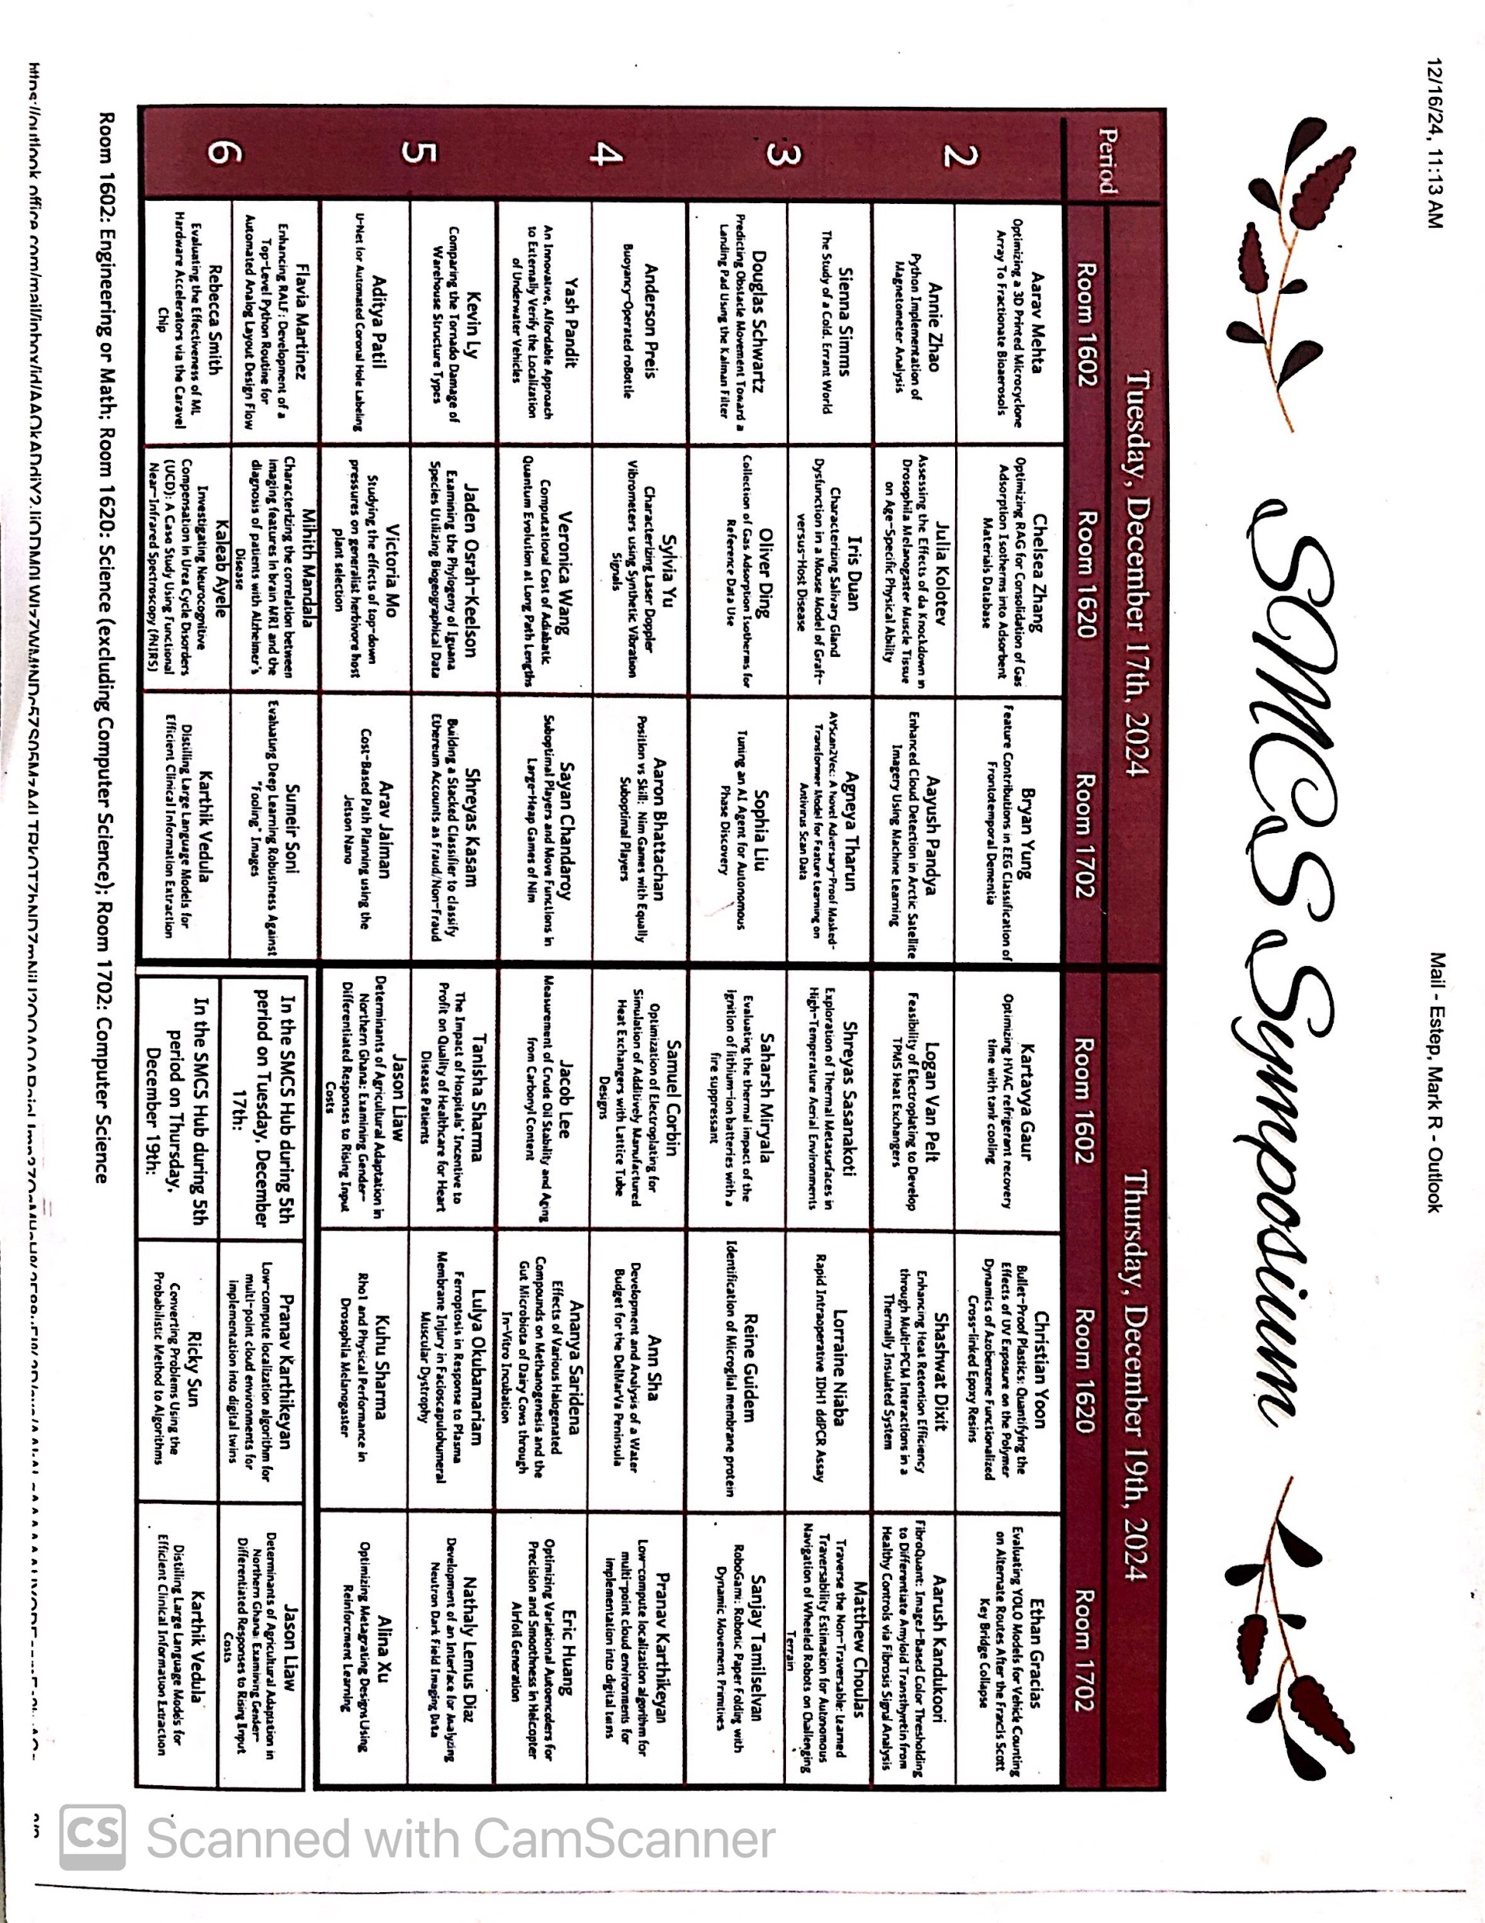
FR1. Schedule Generator
- Automatically generate a schedule based on all the constraints, given that there are no scheduling conflicts for students, junior presiders, or teachers.
- Optimize for distribution based on the internship topic (presentations are grouped by room based on their general topic: Computer Science, Biology, Engineering, or Math).
- Constraint priorities for presentation assignments can be set to the creator’s preference.
- Alert users if no valid schedule can be generated, then offer the closest alternatives.
FR2. Data Storage
- Store generated schedules where users may access them at any time.
- Local storage (5MB) for larger pieces of data like saving schedules.
- Cookies (4KB) for saving login info and previous interactions.
- Allow export as a CSV file.
FR3. Manual Adjustments
- Allow users to interact with the schedule of their choice and manually adjust the schedule to their preference.
- Allow for any changes without the need to regenerate schedules, while also making it easy for the user to edit and make new schedules.
FR4. Data Importation
- Allows users to upload class data and constraints via CSV or Google Sheets.
- Automatically parse imported data for formatting or spelling errors.
- Provide visual feedback or error messages if the uploaded data is invalid or incomplete.
The client provided minimal specific requirements, focusing only on core goals such as automated schedule generation and ChromeOS compatibility. The committee emphasized flexibility and giving the developers significant creative freedom in the design of the system. As a result, much of the system’s structure, features, and implementation details may be left up to the discretion of the programming team.

3.2 External Interface Requirements
Software Interface: Integrate with Google Sheets or CSV file import to allow upload of class data.
User Controls:
- “Upload” button to allow users to upload class data files.
- “Generate” button to initiate the schedule generation process.
Constraint Selection: Drag and drop interface that allows users to select a certain type of constraint (Restriction or Time) into the Constraints list and edit the details.
- Restriction:
  - The user will be able to account for students who will be absent on specific days, and the program will exclude those students from the schedule on those days.
  - The user will also be able to set rules between students to ensure that certain individuals either present together or are scheduled in separate time blocks.
- Time:
  - The user will be able to set time restrictions for certain individuals, fixed time slots (specific times when certain presentations should occur), and time preferences for individuals, which the program will prioritize space for.
Note: Although this covers most, if not all, of the constraints addressed by our client, any additional constraint types or customization features will be discussed with the client prior to implementation.
Constraints list: Displays current user constraints and allows users to order constraints based on priority and remove constraints as needed.

3.3 System Features
The system will contain two buttons for simplicity. One will be used to upload a file that contains the unsorted items, and the other will be a generate button which allows for the generation of multiple schedules. Upon generation, several optimal scheduling possibilities will be given for comparison.

3.4 Nonfunctional Requirements
Nonfunctional requirements specify the system’s quality attributes such as usability, compatibility, maintainability, and security. They define how the system performs and behaves rather than what it does, ensuring that the system is practical, efficient, and sustainable.

Nonfunctional requirements are referenced by the letters NFR (Nonfunctional Requirement), followed by a unique numeric identifier starting from 1.
NFR1. Maintainability
- Editable by developers to fix bugs or errors.
- System can undergo short maintenance periods as needed.

NFR2. MCPS Compliance
- Complies with MCPS data handling policies.
- Avoids third-party tools that do not meet school security standards.
NFR3. Platform Compatibility
- Fully compatible with ChromeOS.
- Optimized for efficient performance on Chrome browser and Chromebooks.
- Tailored for ChromeOS-specific features and limitations.

NFR4. Usability
- Intuitive and simple interface for students and teachers.
- Clean UI elements and accessible instructions.

NFR5. Security Requirements
- Admin/editor access for only teachers and committee members protected by password.
- View-only access for students not involved in scheduling.
NFR6. Scalability
- Handles increases in users and data volume.
- Supports new feature integration without full system redesign (modularity).

